The title of your paper, Capitalize first letter
First Author (First Name Last Name)^{1,a}, Second Author^{2,b}*, Third Author^{2,c}
¹First affiliation, Address, City and Postcode, Country
²Second affiliation, Address, City and Postcode, Country
ªemail, ^{b}email, ^{c}email
*please mark the corresponding author with an asterisk

Abstract. Abstract should not exceed 250 words. The Abstract should state the principal objectives and the scope of the research, as well as the methodology employed. It should summarize the results and state the principal conclusions.
Key words. Not more than 10 significant key words should follow the abstract to aid indexing.
1 Introduction
All papers should be no less than 4 pages and no more than 8 pages in length. For the paper, please use Times Roman (Times New Roman) 10. Footnotes should be avoided. Here follows further instructions for authors.
  - The format of the manuscript
The manuscript should be written in the following format:
Introduction. This part should include the objectives of the work and its background. It should be based on the literature review. In the literature review you should show the competence in your area and its main authors and works. The recommended quantity of references is 15-25. The cited papers should be relatively recent (not older than 15 years). A Theory or experimental methods used.
An Experimental section, which should provide details of the experimental setup and the methods used for obtaining the results
A Results section, which should clearly and concisely present the data using figures and tables where appropriate.
A Discussion section, which should describe the relationships and generalizations shown by the results and discuss the significance of the results making comparisons with previously published work. (It may be appropriate to combine the Results and Discussion sections into a single section to improve the clarity).
Conclusions, which should present one or more conclusions that have been drawn from the results and subsequent discussion and do not duplicate the Abstract.
Acknowledgements. The personal acknowledgements and also the information about funding is given here.
References, References are cited in the text by square brackets [1]. Two or more references at a time may be put in one set of brackets [3, 4]. The references are to be numbered in the order in which they are cited in the text (e.g., "as discussed by Smith [9]"; "as discussed elsewhere [9, 10]"). All references should be cited within the text; otherwise, these references will be automatically removed.
  - Structure
Files must be in MS Word only. Figures and tables should be embedded and not supplied separately.
Please make sure that you use as much as possible normal fonts in your documents. Special fonts, such as fonts used in the Far East (Japanese, Chinese, Korean, etc.) may cause problems during processing. To avoid unnecessary errors you are strongly advised to use the ‘spellchecker’ function of MS Word.
  - Tables
All tables should be numbered with Arabic numerals. Every table should have a caption. Headings should be placed above tables, left justified. Only horizontal lines should be used within a table, to distinguish the column headings from the body of the table, and immediately above and below the table. Tables must be embedded into the text and not supplied separately. Below is an example which the authors may find useful.
Table 1.An example of a table.
An example of a column heading | Column A (t) | Column B (t)
And an entry | 1 | 2
And another entry | 3 | 4
And another entry | 5 | 6
  - Construction of references
References must be listed at the end of the paper. Do not begin them on a new page unless this is absolutely necessary. Authors should ensure that every reference in the text appears in the list of references and vice versa. Indicate references by [1] or [2,3]in the text.
Some examples of how your references should be listed are given at the end of this template in the ‘References’ section, which will allow you to assemble your reference list according to the correct format and font size.
  - Section headings
Section headings should be left justified, bold, with the first letter capitalized and numbered consecutively, starting with the Introduction. Sub-section headings should be in capital and lower-case italic letters, numbered 1.1, 1.2, etc, and left justified, with second and subsequent lines indented. All headings should have a minimum of three text lines after them before a page or column break. Ensure the text area is not blank except for the last page.
  - General guidelines for the preparation of your text
Avoid hyphenation at the end of a line. Symbols denoting vectors and matrices should be indicated in bold type. Scalar variable names should normally be expressed using italics. Weights and measures should be expressed in SI units. All non-standard abbreviations or symbols must be defined when first mentioned, or a glossary provided.
- Illustrations
All figures should be numbered with Arabic numerals (1,2,3,….). Every figure should have a caption. All photographs, schemas, graphs and diagrams are to be referred to as figures. Line drawings should be good quality scans or true electronic output. Low-quality scans are not acceptable. Figures must be embedded into the text and not supplied separately. In MS word input the figures must be properly coded. Preferred format of figures are PNG, JPEG, GIF etc. Lettering and symbols should be clearly defined either in the caption or in a legend provided as part of the figure. Figures should be placed at the top or bottom of a page wherever possible, as close as possible to the first reference to them in the paper. Please ensure that all the figures are of 300 DPI resolutions as this will facilitate good output.
The figure number and caption should be typed below the illustration in 8 pt and left justified [Note: one-line captions of length less than column width (or full typesetting width or oblong) centered]. For more guidelines and information to help you submit high quality artwork please visit: http://www.elsevier.com/artworkinstructions Artwork has no text along the side of it in the main body of the text. However, if two images fit next to each other, these may be placed next to each other to save space. For example, see Fig. 1.

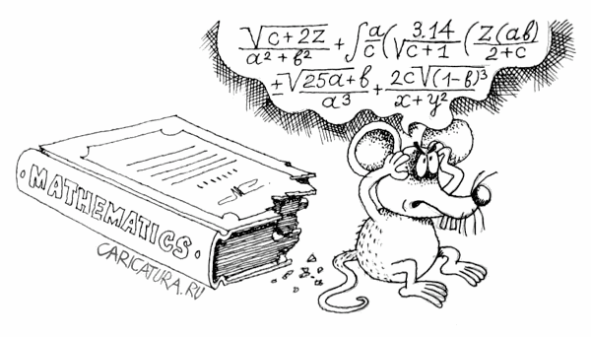
Fig. 1. (a) first picture; (b) second picture.
- Equations
Equations and formulae should be typed in Mathtype, and numbered consecutively with Arabic numerals in parentheses on the right hand side of the page (if referred to explicitly in the text). They should also be separated from the surrounding text by one space.
(1)
4. Online license transfer
All authors are required to complete the Procedia exclusive license transfer agreement before the article can be published, which they can do online. This transfer agreement enables Elsevier to protect the copyrighted material for the authors, but does not relinquish the authors’ proprietary rights. The copyright transfer covers the exclusive rights to reproduce and distribute the article, including reprints, photographic reproductions, microfilm or any other reproductions of similar nature and translations. Authors are responsible for obtaining from the copyright holder, the permission to reproduce any figures for which copyright exists.
Acknowledgements
Acknowledgements and Reference heading should be left justified, bold, with the first letter capitalized but have no numbers. Text below continues as normal.
References
[1] J. Van der Geer, J.A.J. Hanraads, R.A. Lupton, The art of writing a scientific article, J. Sci. Commun. 163 (2000) 51–59.
[2] W. Strunk Jr., E.B. White, The Elements of Style, third ed., Macmillan, New York, 1979.
[3] G.R. Mettam, L.B. Adams, How to prepare an electronic version of your article, in: B.S. Jones, R.Z. Smith (Eds.), Introduction to the Electronic Age, E-Publishing Inc., New York, 1999, pp. 281–304.

